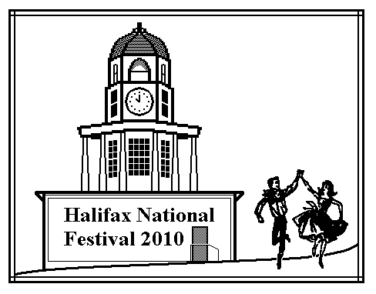
Halifax National Festival 2010
July 29, 30 & 31, 2010

World Trade & Convention Centre / Metro Centre
Halifax, Nova Scotia, Canada

Square Dance Caller Profile
Dear Caller: Thank you for volunteering to call at our National Festival. Please fill out the following questionnaire regarding your programming desires and abilities by March 15, 2010.
Caller's Name: Partner's Name:
Mailing Address:

E-mail:
Phone: Fax:
Home Location for Introduction Cards:
Square Dance Calling History:
Number of years calling: _____ Current number of dances called per year: _____
Programs regularly called: Basic____, MS____, Plus____, A1____, A2____, C1____, C2____, C3___
Number of Canadian National Conventions/Festivals called for: ________ Other Nationals: _________
I am a National Caller ______; a Regional Caller ______; a Local Caller ______; a Club Caller ______.
I belong to the following Caller Organizations/Associations:

Programming Information: There will be regular Patter and Singer Tips, Singing Call Tips, Intro to Next Level Tips, and Non-Standard Workshop Tips. Please check each of the Program and Tip types you would like to call. (A check in the Mainstream column for "Intro to Next" means you would call an Intro to Plus in the Mainstream hall.) Are you willing to be an MC at Mainstream or Plus? ___________
 | Basic | Mainstream | Plus | A1 | A2 | C1 | C2 | C3A
Tip
Singing Only
Intro to Next
N-S Workshop
Programming Availability: Please check each time when you are available and indicate how much calling you would like to do during the convention. Multi-level callers please indicate your preference regarding halls and busy schedules. (The National Society Meeting is Friday Morning.)
 | Morning | Afternoon | Evening | Comments:
Thursday |  |  |  | Comments:
Friday |  |  |  | Comments:
Saturday |  |  |  | Comments:
I am also a leader in: Rounds ____ Contra ____ Clogging ____ Line Dancing ____ Education ____
Is your partner/spouse also programmed? ______ Will you be available Wednesday night? _______
Would you like to call a New Dancer Tip? ________ Please add any other pertinent information below:

E-mail to: Terry Hebert <sdcaller@nbnet.nb.ca> and copy to Dottie Welch <dwelch@ap.stmarys.ca>
Or mail to Dottie Welch, 415 Conrad Road, Lawrencetown, NS, Canada, B2Z 1S3 Phone: 902-435-4544


Promenade to Halifax in 2010

17th Canadian National Square & Round Dance Convention

