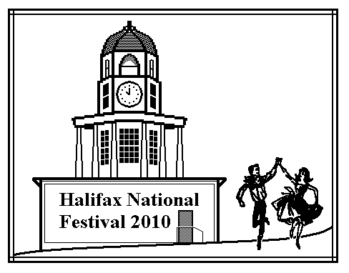
Halifax National Festival 2010
July 29, 30 & 31, 2010

World Trade & Convention Centre / Metro Centre
Halifax, Nova Scotia, Canada

Round Dance Cuer Profile
Dear Round Dance Leader:
Thank you for offering to take a leading role at our Festival. A successful program would not be possible without the commitment of leaders like yourselves. If you have not already been contacted by John Pinks, please answer the following questions and return to John as soon as possible.

Experience:
At what level do you routinely cue and teach in round dancing? How long have you been involved?

Programming Information for Festival 2010:

1. At what level do you wish to cue?

2. At what level and rhythm would you prefer to teach?

3. Do you want to present a workshop? If so at what level and rhythm?

4. Are you prepared to act as a Master of Ceremonies ?

5. On which days Thurs - Fri - Sat would you prefer to participate?

6. Are you also a leader in another type of event at Festival 2010?
Squares ____ Contra ____ Clogging ____ Line Dancing ____ Education ____

Is your partner/spouse also programmed? ______ Will you be available Wednesday night? _______

Please add any other pertinent information:

Clearly we will not be able to satisfy everyone's detailed preferences but we will do our best in this respect.
John and Valerie Pinks, Round Dance Programmers, <jandvpinks@cs.com>, 902-823-2230
11 MacDonald Point Road, Seabright, NS, Canada, B3Z 2Y2


Promenade to Halifax in 2010

17th Canadian National Square & Round Dance Convention

